1.Download code and put it in any folder

2.Go to that particular folder in cmd using cd command

3.And run mvn clean install ( to clean target folder and build new jar file)

- Go to target folder and run
Java -jar jarpackagename

5.In console you will see port assigned to it
(I have used setting so that every time it takes up any of the free port.)

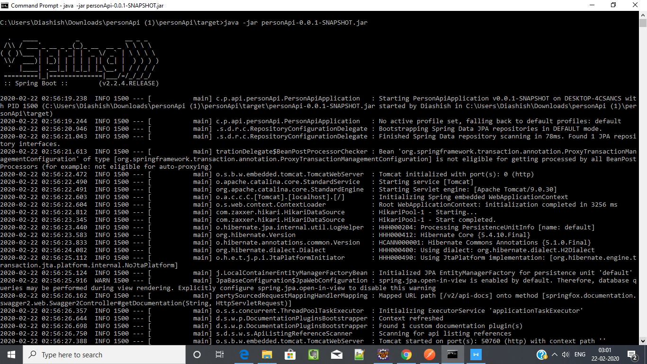

Access Swagger-ui.html by appending port on which Spring started
http://localhost:50760/swagger-ui.html

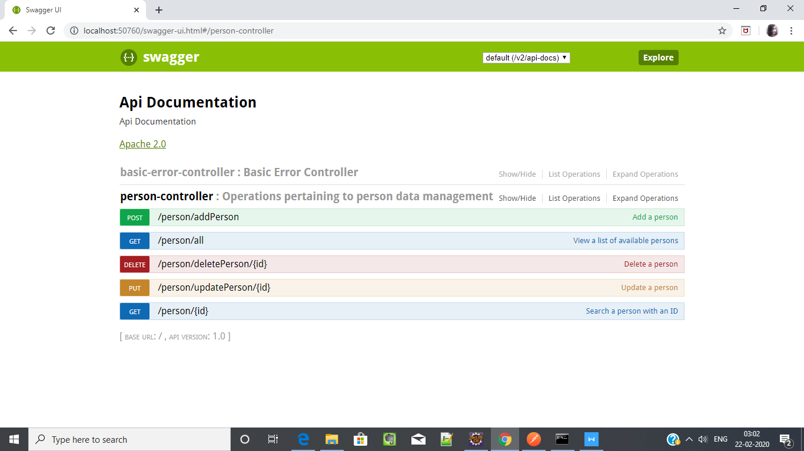

We can use ui to access all the apis required I.e.
Get all person
Get a person by id
Create a person
Update a person
Delete a person

